1. Agenda:
   1. What is JWT?
   2. When to use?
   3. What is structure?
   4. How it works?
2. 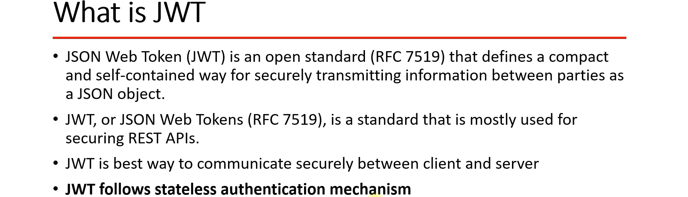
3. 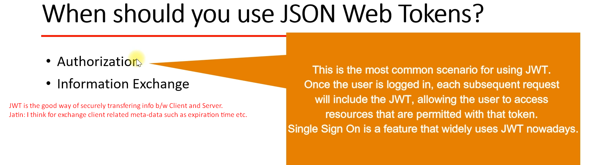
4. 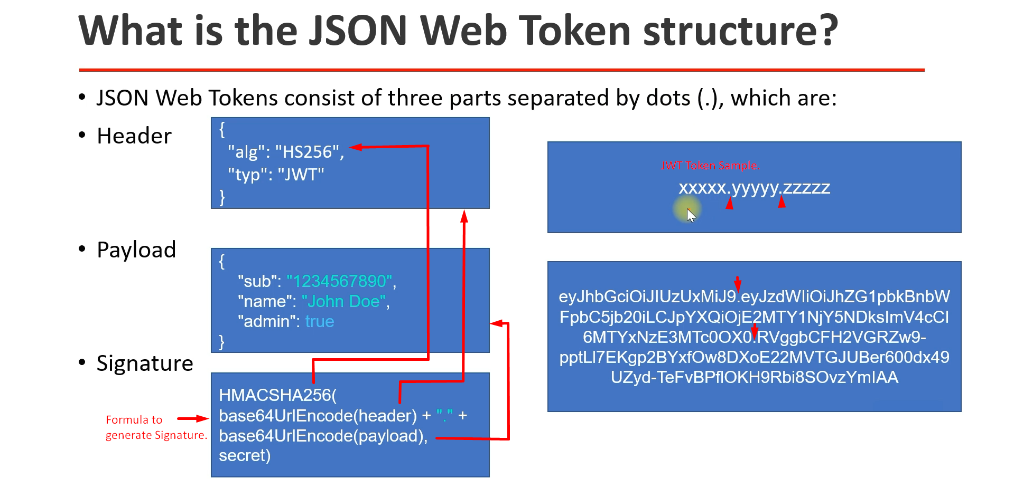
   1. **Payload**: Contains claims which are statements about an entity (claims about user, additional info).
      1. Claims about who is the user, what is his role, what is the expiration time.
5. 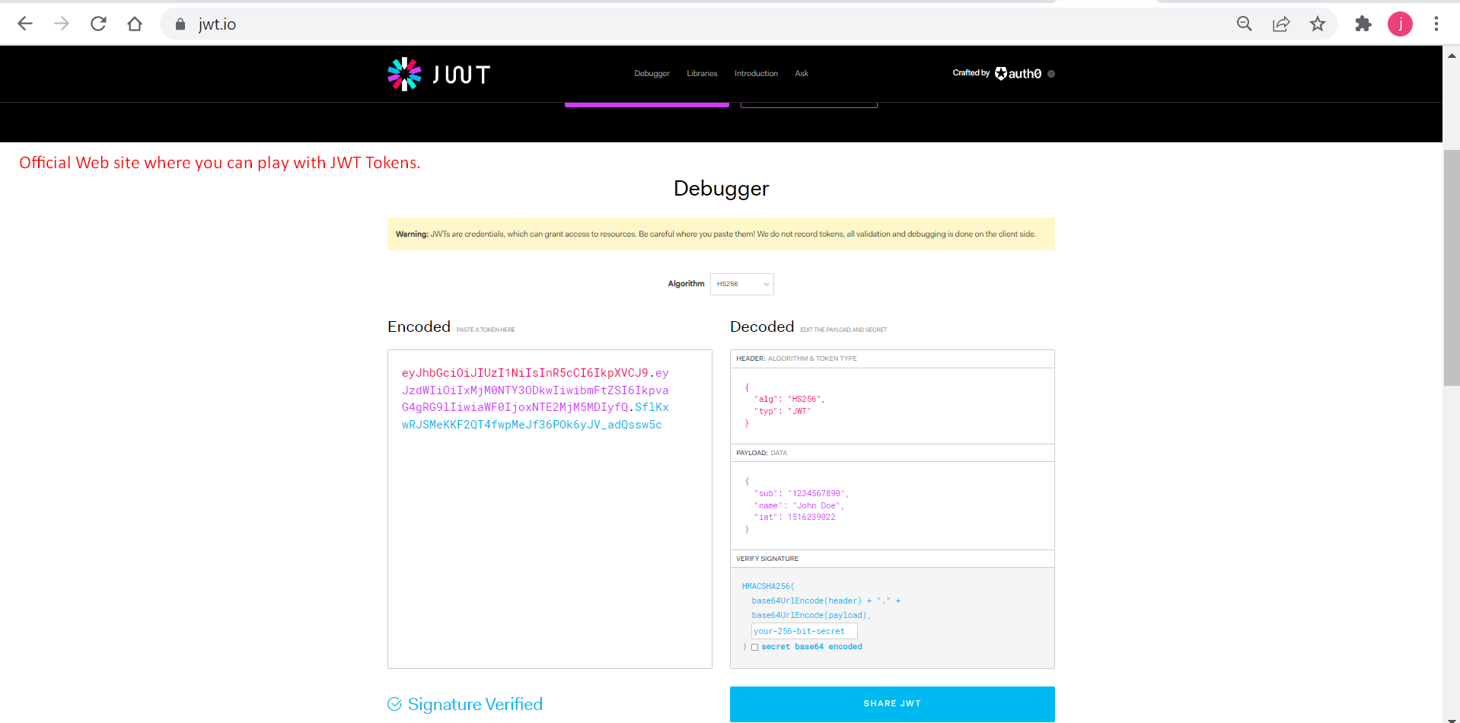
6. 